Oracle 19c Installation on Windows 10 Professional 64 Bit

Is Oracle Database 19c available for all the Windows operating systems?
No, it is not. Oracle Database 19c is only available for –
- Windows 8.1 x64 – Pro and Enterprise editions
- Windows 10 x64 – Pro, Enterprise, and Education editions
- Windows Server 2012 R2 x64 – Standard, Datacentre, Essentials, and Foundation editions
- Windows Server 2016 x64 – Standard, Datacentre, and Essential’s editions
- Windows Server 2019 x64 – Standard, Datacentre, and Essential’s editions

Can we install Oracle DB 19c on x32 bit Windows operating system?
- No, we cannot install Oracle Database 19c on x32bit Windows operating system. Oracle 19c is only compatible with x64bit Windows OS.

The download of Oracle Database 19c is going to be about 3 GB in size.
Click or Go to the link to download Oracle Database 19c - www.Oracle.com/Download
Go to Above link Click on Zip and it will ask you for Oracle User id and Password.
Note - If you have oracle account then use it other wise create a new one and download it.

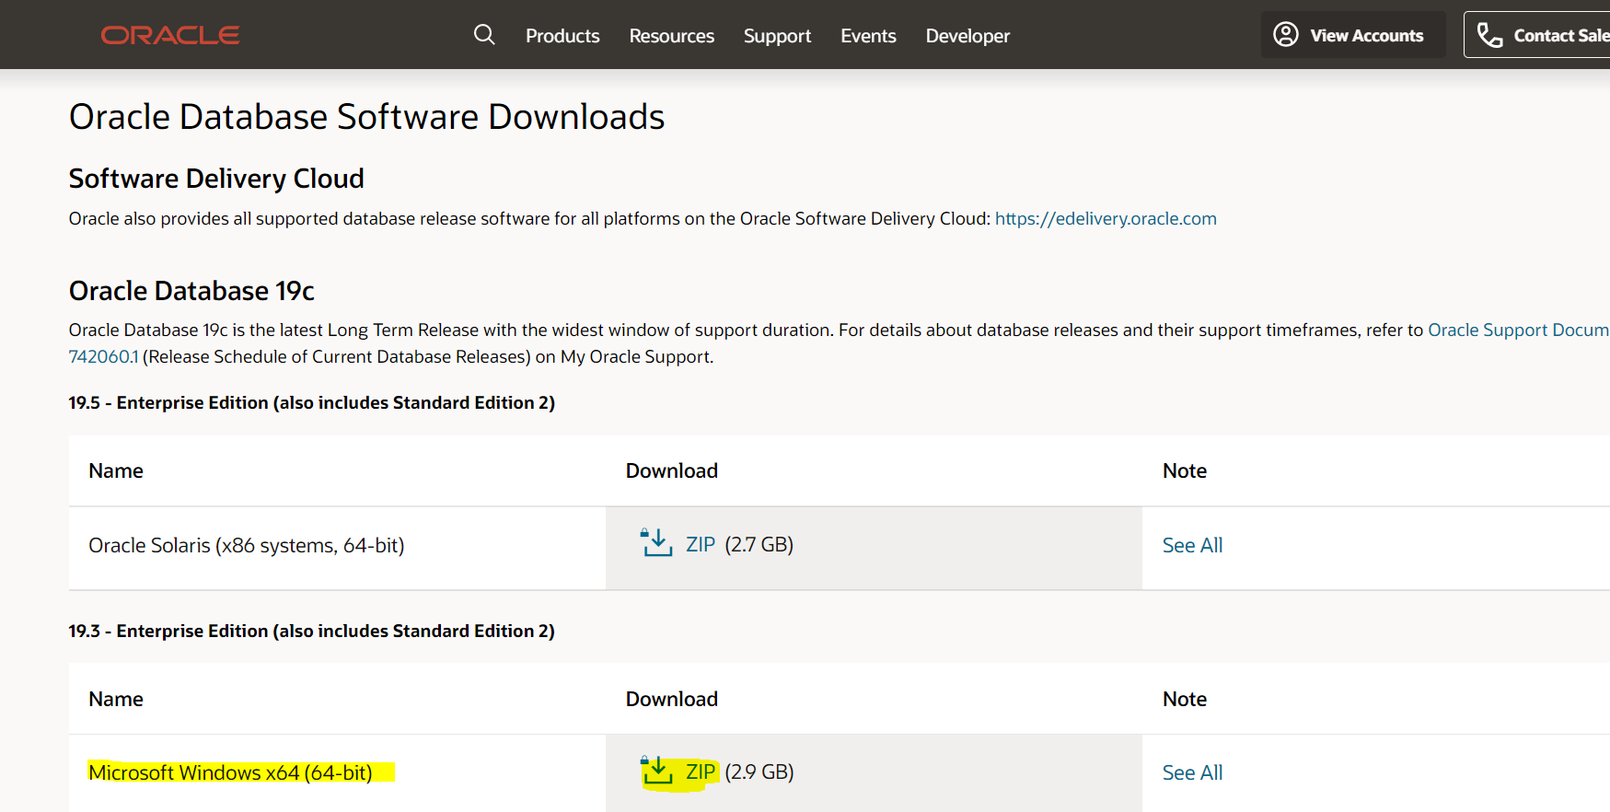

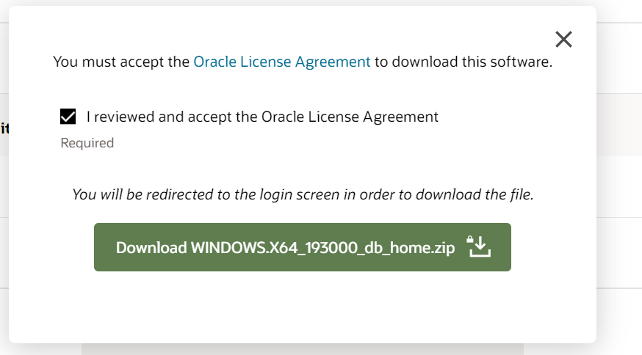
First of all, decide a location. Additionally, it’s recommended to locate your Oracle Home in any partition of your hard disk, except the one which contains your Operating system.
For example. I will create a folder in my D: Drive and name it db_home.
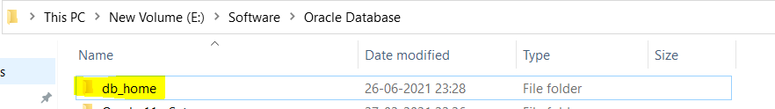
Once download completed – copy the zip file from download folder into db_home folder and extract its content there.

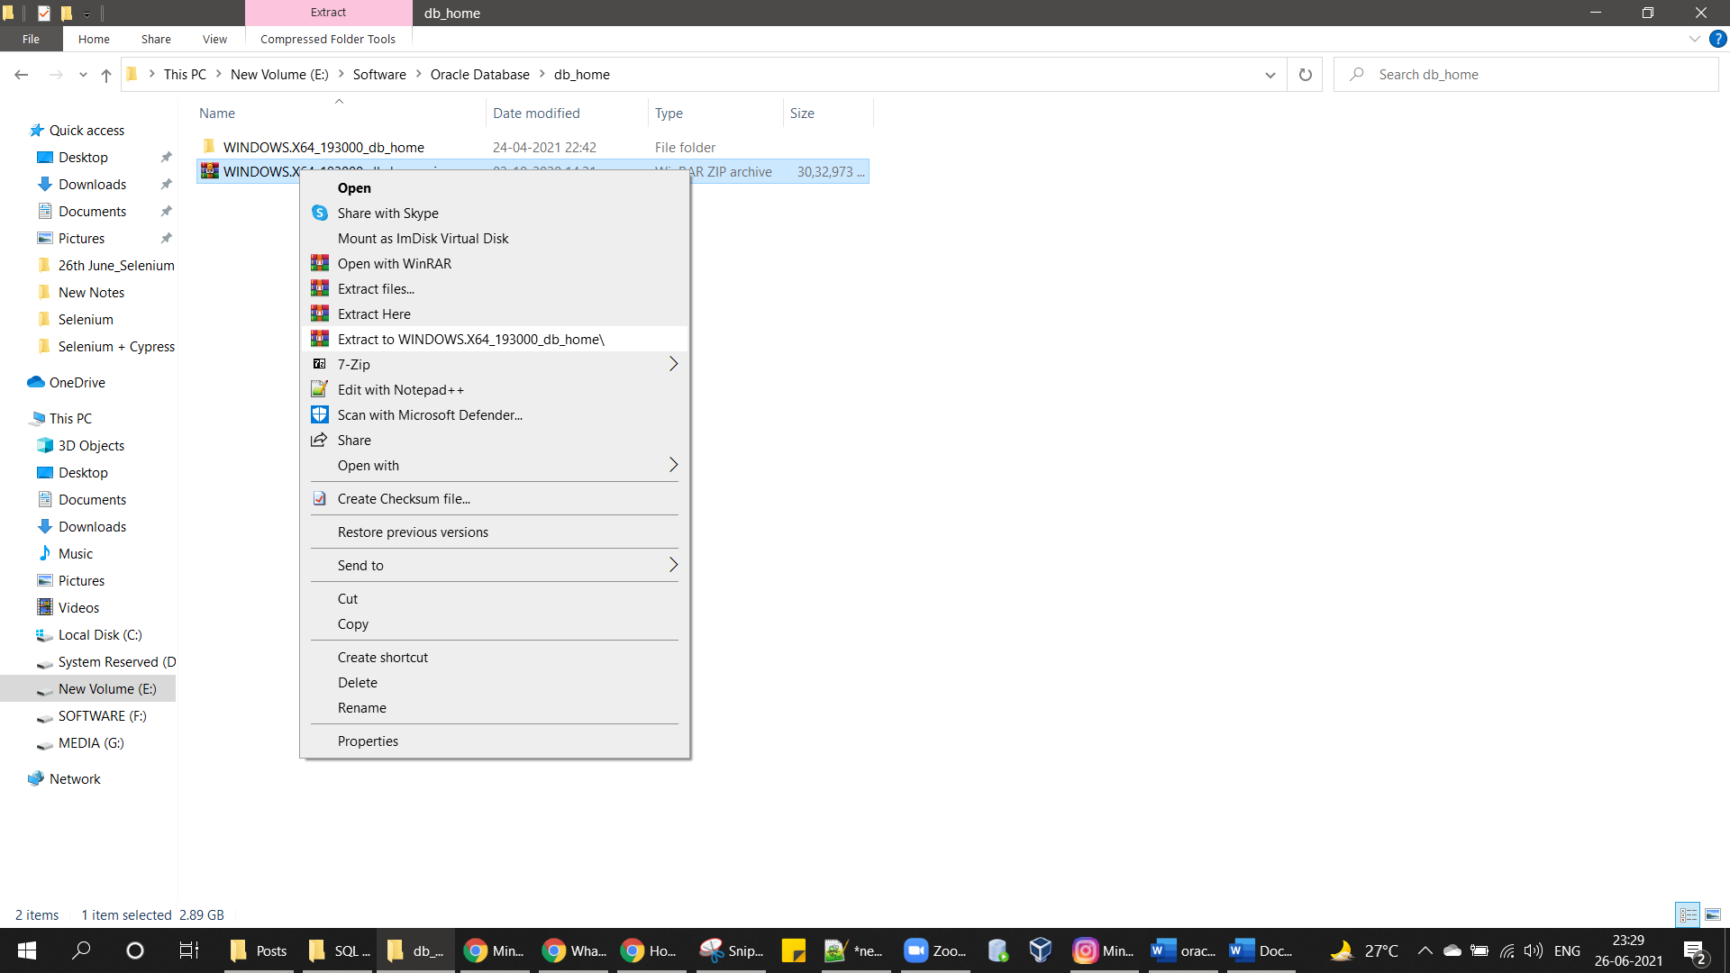

Now we are all set to start the installation process of Oracle Database 19c.
Installation of Oracle DB 19c on Windows 10.

Make sure you are logged on to your windows with an administrative user account.
Go to the \db_home\WINDOWS.X64_193000_db_home path.
Right Click on setup.exe

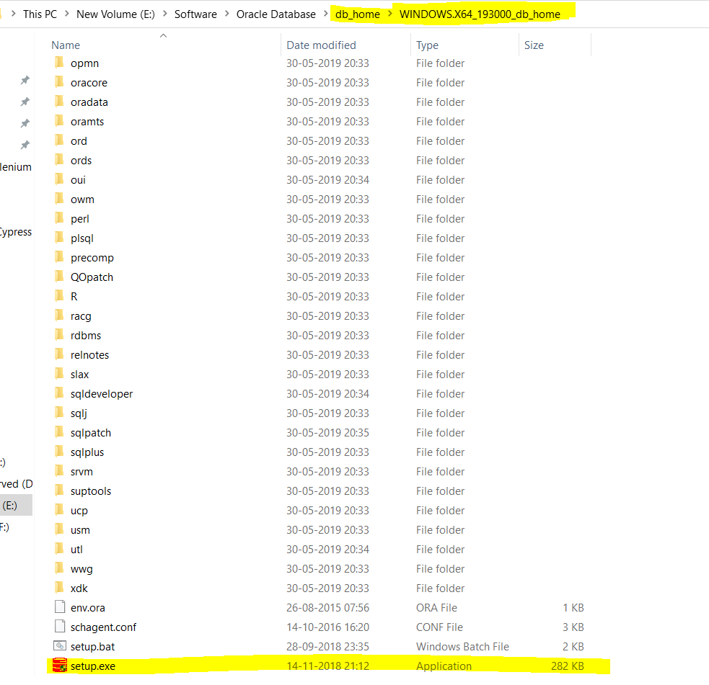

Click on Run as Administrator
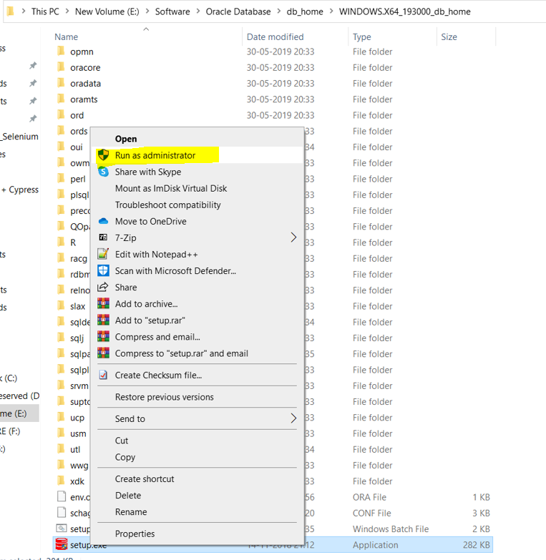

Screen 1: Configuration Option
Select the highlighted option and click NEXT

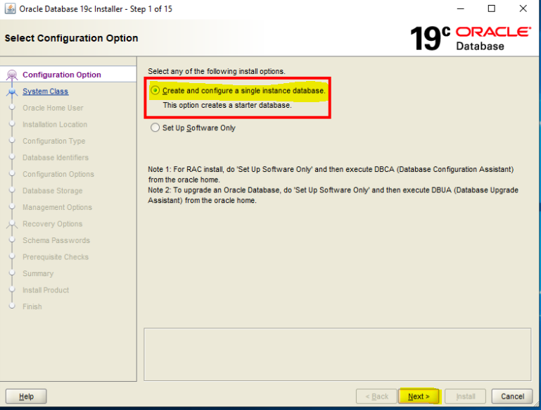

Screen 2: Select System Class.
Select the highlighted option and click NEXT

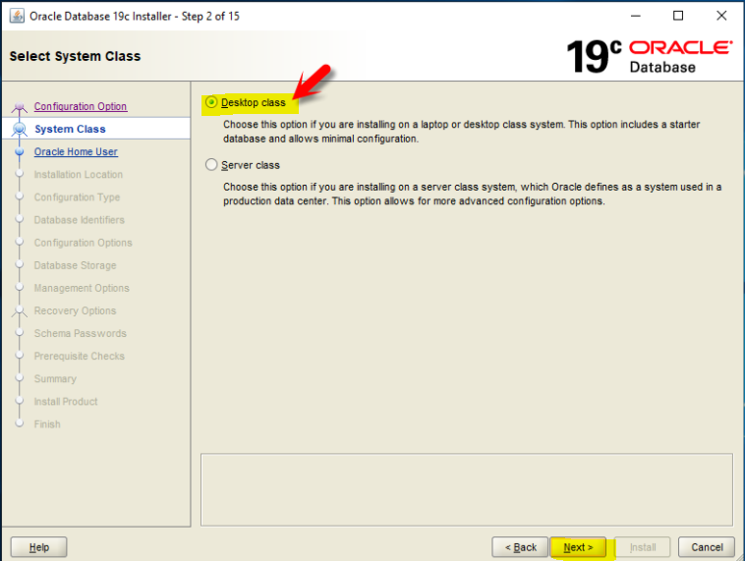

Screen 3: Specify Oracle Home User.
Select the highlighted option i.e., Use Windows Built in Account and click NEXT

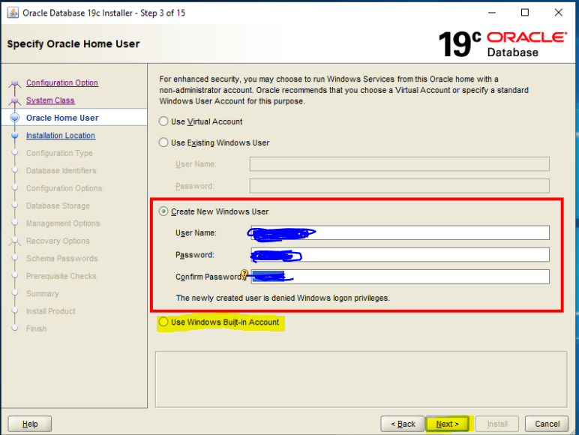

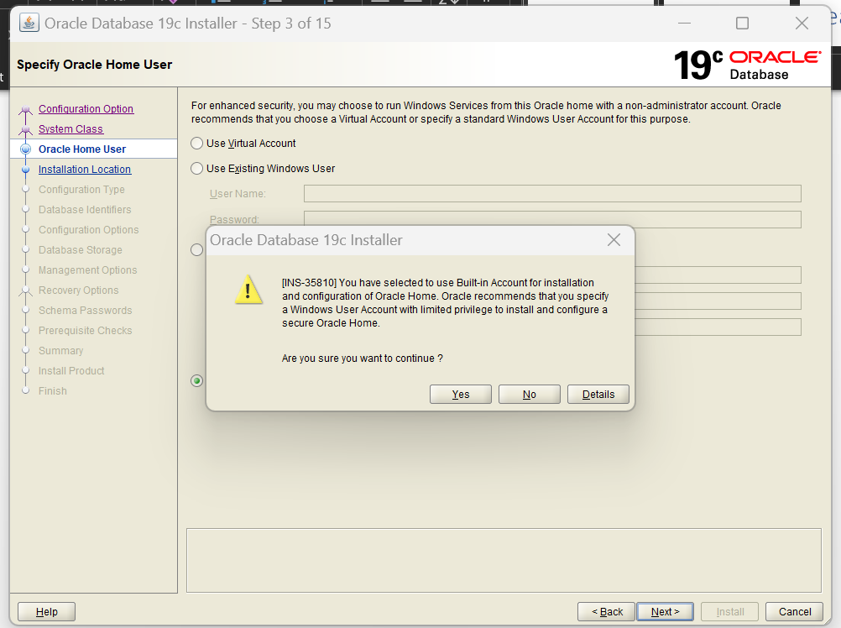
Screen 4: Typical Installation.
Provide the password and keep it somewhere and note down the Pluggable database name and click NEXT
Note – no need to changes the Pluggable database name
To remember password, keep password as oracle only
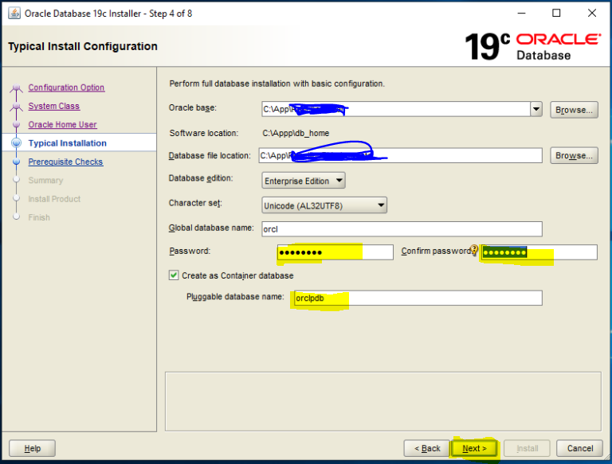
Click on YES

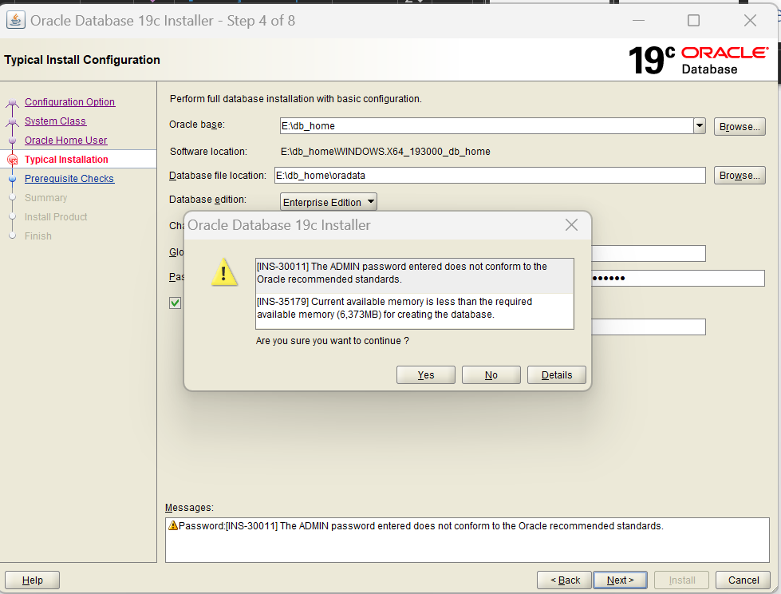
Screen 5: Prerequisite Checks
It will check the Prerequisites first
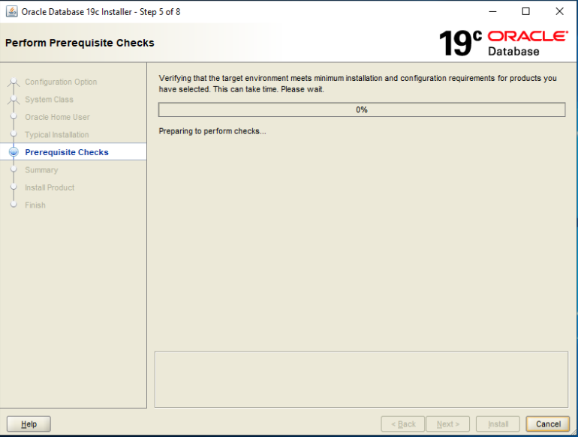

Screen 6: Summary
Click on Install
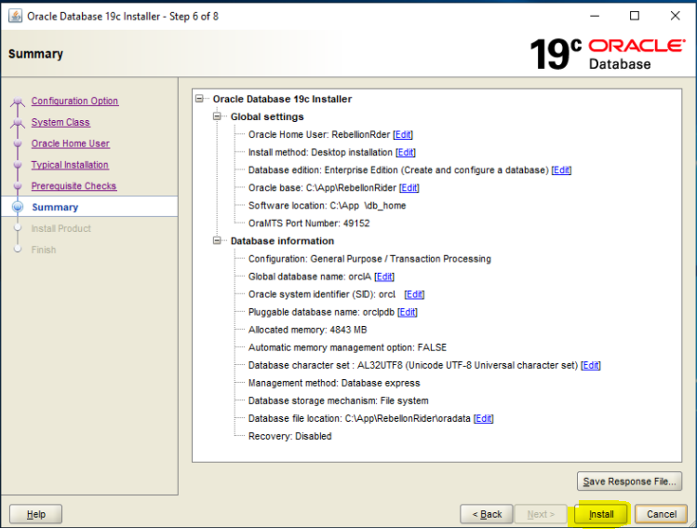

Once database Successfully installed then click on Close
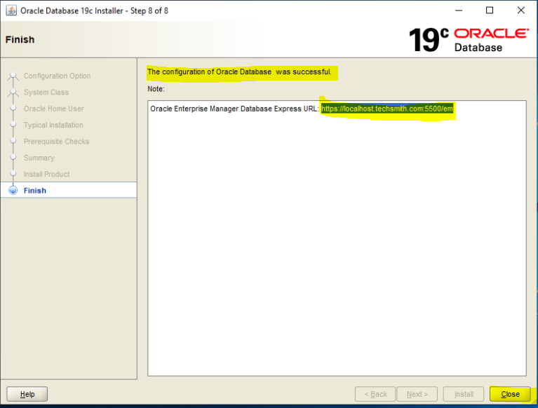

***************************************************************************

Now Install SQL Developer on Windows 10
Click or Go to Below link to download the SQL Developer-
https://www.oracle.com/tools/downloads/sqldev-downloads.html

Click on Download -
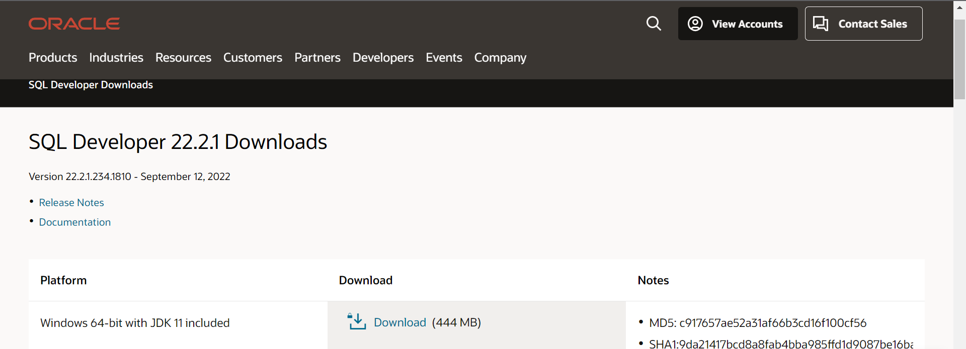

Accept the Agreement and click on Download SQL developer button-
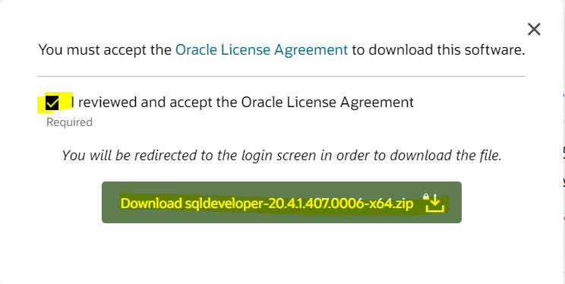
Once download completed – copy the zip file from download folder into other drive folder and extract its content there.

Now Open the folder and right click on sqldeveloper.exe file and Run As Administrator
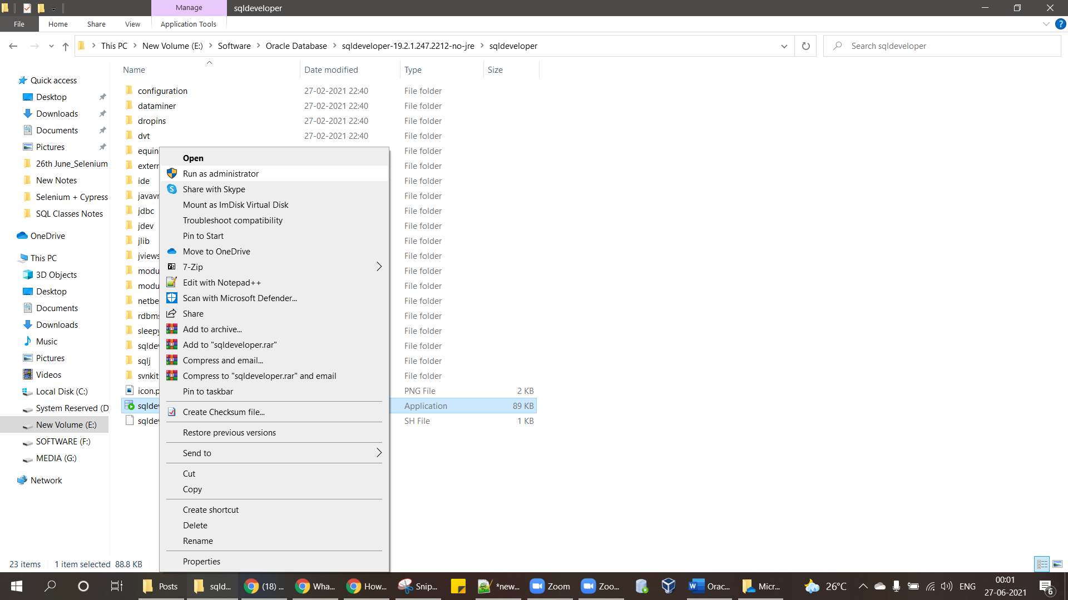

It will start Installing sql developer
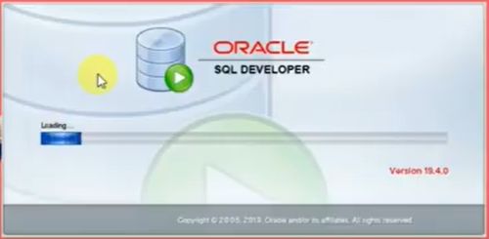
Click on OK
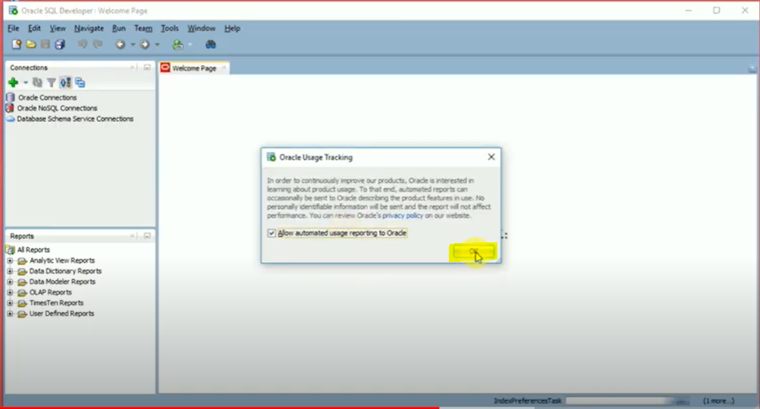

Click on + Symbol to create connection with Database -
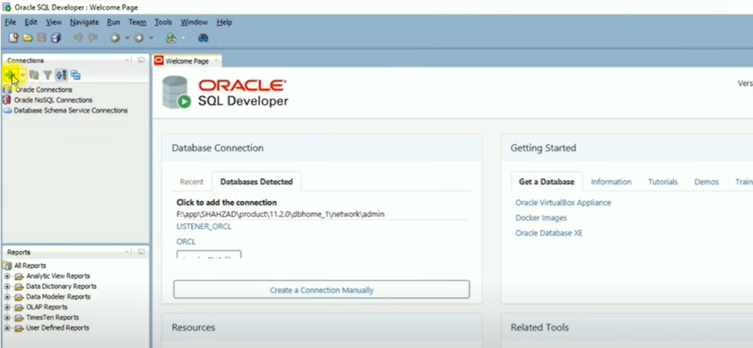
Name – Any Suitable Name
Username – sys
Password – Provide the password which we provided at the time of installing Database
Hostname – keep As it is, No need to change
Select Service Name – Provide the Pluggable database name here
Role – Select SYSDBA from Drop down
Click on Save Password
First Click on Test Button
Second Click on Save Button
Third Click on Connect Button

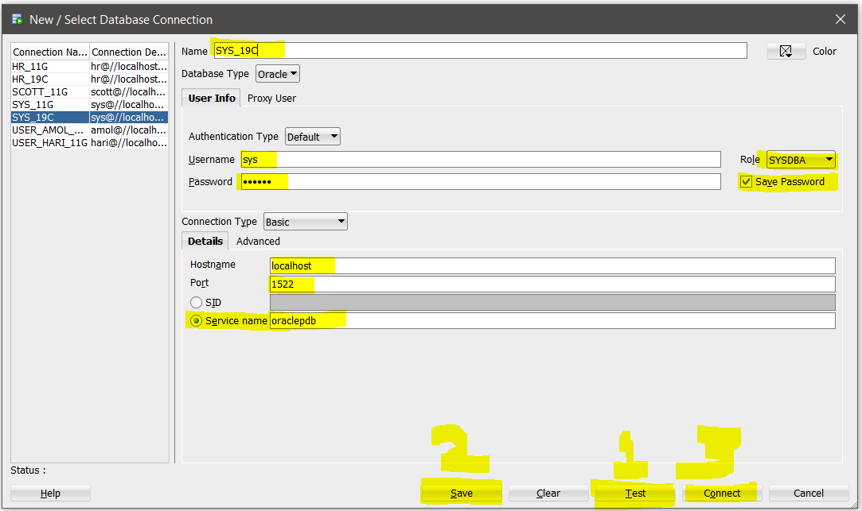
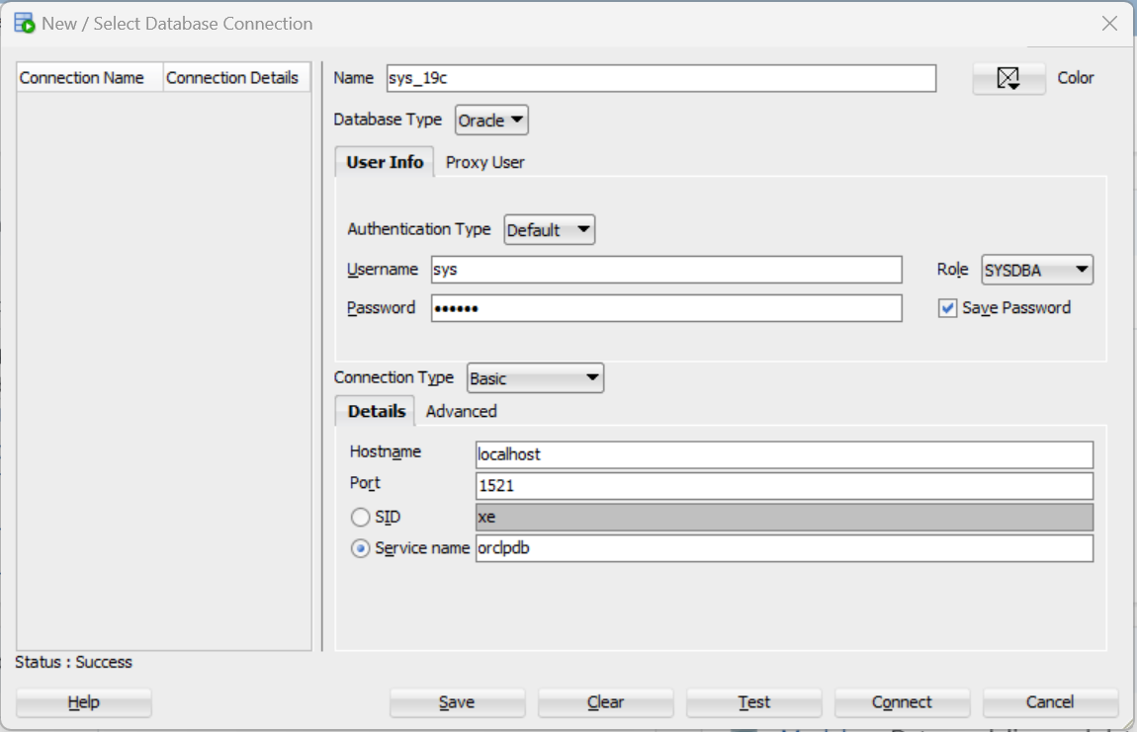

Connect to ORACLE using SQL*Plus
Go to windows search bar and search for SQL plus
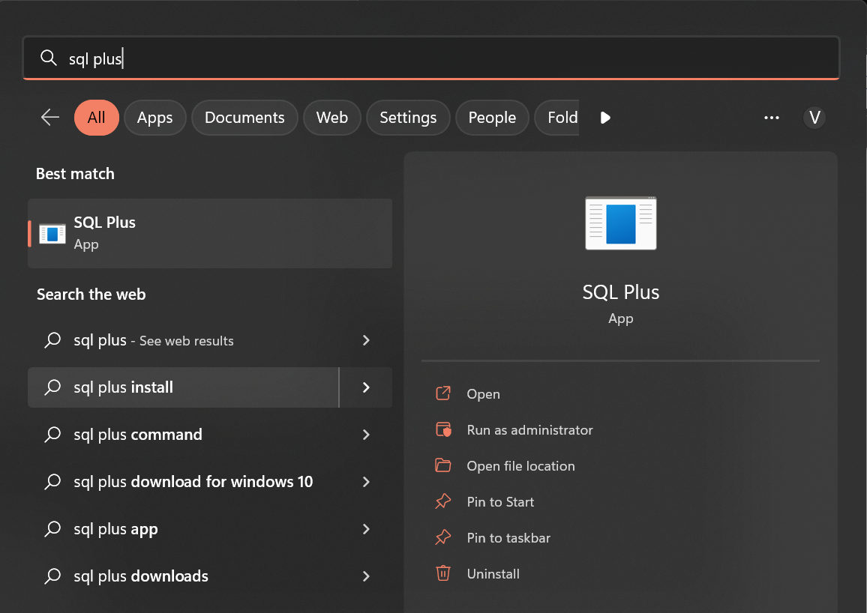
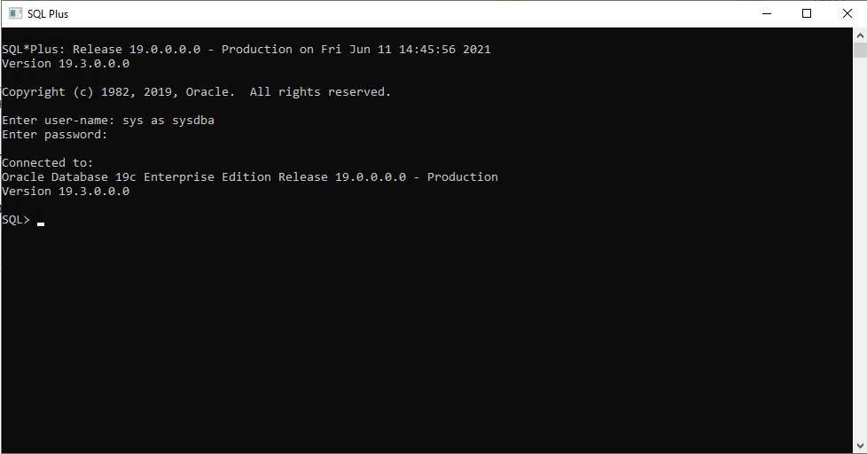

As you can see, we are connected to the oracle using the sys user. Now, let us run some simple queries.

Enable HR schema and Run basic Queries
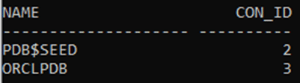

We can get all this information from the listener.ora file. This file is located in the path E:\db_home\WINDOWS.X64_193000_db_home\network\admin. You can also search for this file in your windows explorer. Open this file in notepad and go to the following entry :
Creating a TNS entry
In this step, we will manually add the TNS entry for our pluggable database orclpdb.
- Locate the tnsnames.ora file. It will be located in the same path as the listener.ora file in \app\db_home\network\admin.
- Open this file in notepad, copy/paste the last entry in this file and modify it with the information we gathered in the previous step from listener.ora i.e add the service name, protocol, host and port values. Your last entry may look like the one shown:
- Copy and paste it at the end of the file.
- Modify the new entry. After the changes, your new entry should look like:
ORCLPDB =
(DESCRIPTION = (ADDRESS = (PROTOCOL = TCP)(HOST = localhost)(PORT = 1521))
(CONNECT_DATA =
(SERVER = DEDICATED)
(SERVICE_NAME = orclpdb)
)
)
Save and close tnsnames.ora file.

Restart the Listener
- Minimize or close the previous command (cmd) prompt. In your windows start program, type cmd and open it by selecting run as administrator.
- Execute the following statement – lsnrctl reload
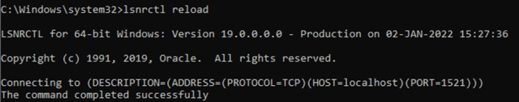

UNLOCKING HR USER IN ORACLE 19C

- On the cmd, connect using sys user with sysdba privileges. Use the command
